NATIONAL INSTITUTE OF TECHNOLOGY, KURUKSHETRA
BT4/5-2010
THEORY EXAMINATION
Question Paper
Month and Year of the Examination: May/June-2010
Programme: B.Tech Semester: - 4th Semester
Subject: - Microprocessor-I
Course No: -COT-208 Maximum Marks: - 50
Number of Questions to be attempted: -5 Time allowed: - 3 Hours
Total No. of Questions: -8 Total No. of Pages used: -2
Unless stated otherwise, the symbols have their usual meanings in context with subject. Assume suitably and state, additional data required, if any. The Candidates, before starting to write the solutions, should please check the question Paper for any discrepancy, and also ensure that have been delivered the question paper of right course no. and right subject title.

Note: - Attempt any five questions
 | (a)Q:-What do you mean by pipelined architecture? How is it implemented in 8086?  (b)Q:-Explain the following signals of 8086:-  - LOCK(active low)  - READY(active high)  - ALE(active high)  - DEN(active low)  - RQ/GT(active low) | 5  5
 | (a)Q:-Explain the addressing modes for control transfer instructions.  (b)Q:-Explain the following instructions of 8086 with example:-  - XLAT  - LEA  - LDS/LES  - TEST  - LODS | 5  5
 | (a)Q:-Write a program to convert an 8-bit binary number into equivalent gray code.  (b)Q:-Define macro with its syntax. Also explain the similarities and differences between macro and subroutine. | 5  2+3
 | (a)Q:-Write ALPs to generate the 5 sec delay using a microprocessor system that runs at 5 MHz.  (b)Q:-Design a memory system that has total 16K x 8 ROM and 32K x 8 RAM .The ROM and RAM chips are available in modules of 8K x 8. The memory map should be specified below:-  - ROM 1-F0000H-F1FFFH  - ROM2-Decide suitably for practical system (with reason)  - RAM 1- Contains interrupt Vector Table  - RAM 2- 30000H-31FFFH  - RAM 3- 40000H-41FFFH  - RAM 4- 50000H-51FFFH | 5  BT4/5-2010  5
 | (a)Q:-What do you mean I/O port. Write the various steps for interfacing I/O device with 8086.  (b)Q:-Interface an I/O port with 8086 with the help of 74LS245 to read the status of eight switches SW0-SW7 and send the status on eight LEDs attached on output port with the help of 74LS245. The port address of input port is 000Ah and port address of output port is 000Eh. Write an ALP for this task. Also draw the necessary required hardware.  (c)Q:-What do you mean by BSR mode of 8255 PIO. Write ALP to generate a square wave of 50ms on PC2. | 1+2  4  1+2
 | (a)Q:-What do you mean by DMA. Explain with the help of block diagram, how Memory to I/O transfer occurs using DMA.  (b)Q:-Explain the various control signals of 8255 PIO used in Mode 2 configuration. Also explain the Mode 2 Bidirectional data transfer using timing diagram. | 1+4  5
 | (a)Q:-(a) Find the port addresses for figure shown below.  (b):-Find the control word if PA=out, PB=in, PC_{0 –} PC₃ = in and PC4₋ PC₇ = out.  (c):- Program the 8255 to get data from port B and send it to port A. In addition, data from PC_{L} is send out to the PC_{U.}  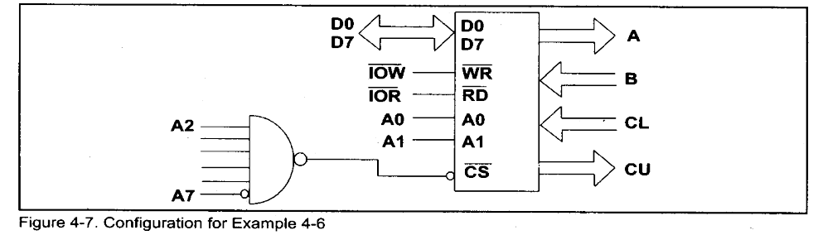  (b)Q:-Interface a 4K X 8 ROM, one chip of 8K X 8 RAM, two chips of  8K X 4 with 8086. The map should be given below:-  One 4K X 8 ROM FF000h-FFFFFh  One 8K X 8 RAM 00000h-01FFFh  Two 8KX 4 RAM 05000h-06FFFh  ( Note: Implement with the help of DMUX only) | 1+1+3  5
 | Q:- Write short note on following topics:-  BT4/5-2010  - Memory Segmentation in 8086  - Physical Memory Organization of 8086.  - Assembler directives.  - NOP and HLT instruction.  - Difference between synchronous and Asynchronous communication. | 2x5=10

